**15B17CI371 – Data Structures Lab**

**ODD 2024**

**Week 0-LAB A**

**Practice Lab**

1. **Write a C/C++ program to find the average of n numbers using arrays**

#include <iostream>

using namespace std;

int main()

{

int n;

double sum=0;

cout<<"Input the value of n : ";

cin>>n;

int *arr=new int[n];

cout<<"Input the numbers :\n";

for(int i=0;i<n;i++)

{

cin>>arr[i];

sum+=arr[i];

}

cout<<"Average : "<<(sum*1.0)/n;

}

**Output :**

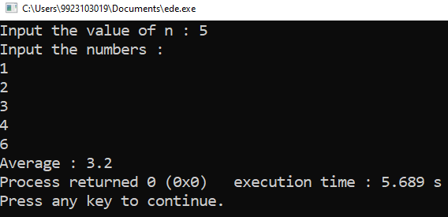

1. **Write a C/C++ program to find the frequency of each element in an array.**

#include <iostream>

using namespace std;

int main()

{

int n,c=0;

cout<<"Input the size of array : ";

cin>>n;

int *arr=new int[n];

cout<<"Input the numbers :\n";

for(int i=0;i<n;i++)

cin>>arr[i];

for(int i=0;i<9;i++)

{

for(int j=0;j<n;j++)

{

if(arr[j]==i)

c++;

}

if(c>0)

cout<<i<<" occurs "<<c<<" times\n";

c=0;

}

}

**Output :**

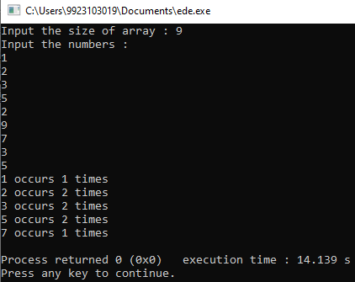

1. **Given an array, write a program in C/C++to left rotate the elements of the array by one.**

#include <iostream>

using namespace std;

int main()

{

int n;

cout<<"Input the size of array : ";

cin>>n;

int *arr=new int[n];

cout<<"Input the numbers :\n";

for(int i=0;i<n;i++)

cin>>arr[i];

cout<<"\nArray Elements before rotating: ";

for(int i=0;i<n;i++)

cout<<arr[i]<<" ";

int temp=arr[0];

for(int i=0;i<n-1;i++)

arr[i]=arr[i+1];

arr[n-1]=temp;

cout<<"\nArray Elements before rotating: ";

for(int i=0;i<n;i++)

cout<<arr[i]<<" ";

}

**Output :**

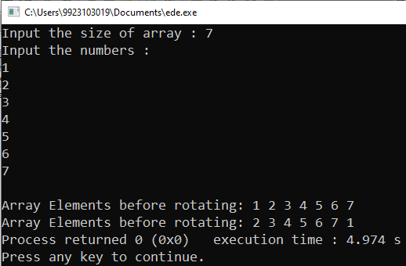

1. **Write a C/C++ program to find the second smallest element in a one-dimensional array.**

#include <iostream>

using namespace std;

int main()

{

int n;

cout<<"Input the size of array : ";

cin>>n;

int *arr=new int[n];

cout<<"Input the numbers :\n";

for(int i=0;i<n;i++)

cin>>arr[i];

cout<<"\nArray : ";

for(int i=0;i<n;i++)

cout<<arr[i]<<" ";

for(int i=0;i<n;i++)

{

for(int j=i+1;j<n;j++)

if(arr[i]>arr[j])

{

int temp=arr[i];

arr[i]=arr[j];

arr[j]=temp;

}

}

cout<<"\nSecond smallest element in array : "<<arr[1];

}

**Output :**

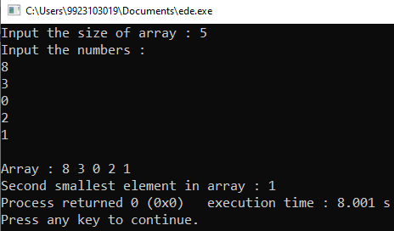

1. **A dynamically created array stores following integer elements (odd and even integers). It is desired to print/display the elements of this array in such manner that it first prints all the even elements then it prints all the odd elements.**

#include <iostream>

using namespace std;

int main()

{

int n;

cout<<"Input the size of array : ";

cin>>n;

int *arr=new int[n];

cout<<"Input the numbers :\n";

for(int i=0;i<n;i++)

cin>>arr[i];

cout<<"\nInput : ";

for(int i=0;i<n;i++)

cout<<arr[i]<<" ";

cout<<"\nOutput : ";

for(int i=0;i<n;i++)

if(arr[i]%2==0)

cout<<arr[i]<<" ";

for(int i=0;i<n;i++)

if(arr[i]%2==1)

cout<<arr[i]<<" ";

}

**Output :**

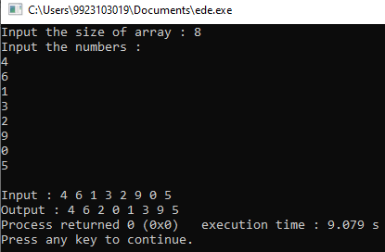

1. **Write a program without STL to create the dynamic array of user inputted length (n), assign values at different indices of the array, and as presented in above example, display the elements of this array.**

#include <iostream>

#include <bits/stdc++.h>

using namespace std;

int main()

{

int n;

cout<<"Input the size of array : ";

cin>>n;

int *arr=new int[n];

for(int i=0;i<n;i++)

arr[i]=rand()%100;

cout<<"Random Array : ";

for(int i=0;i<n;i++)

cout<<arr[i]<<" ";

cout<<"\nOutput : ";

for(int i=0;i<n;i++)

if(arr[i]%2==0)

cout<<arr[i]<<" ";

for(int i=0;i<n;i++)

if(arr[i]%2==1)

cout<<arr[i]<<" ";

}

**Output :**

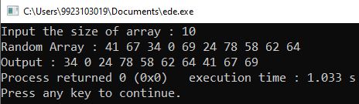

**7.**

**(a)**

Size of o1 : 4

Size of o2 : 16

Size of abc is : 16

**(b)**

Size of o1 : 4

Size of o2 : 24

**(c)**

Size of o1 : 4

Size of o2 : 24

**(d)**

Size of o1 : 4

Size of o2 : 24

**(e)**

Size of o1 : 4

Size of o2 : 16

**(f)**

Size of o1 : 4

Size of o2 : 20

**8.**

**(a)**

4.5

**(b)**

5

**(c)**

44

**(d)**

Error: invalid conversion from 'int*' to 'int'

**(e)**

5

**(f)**

4

**(g)**

5

**(h)**

Garbage value